

FACULTY OF ENGINEERING AND TECHNOLOGY

A REPORT OF THE MATLAB ASSIGNMENT REQUIRING TO DEVELOP AND TEST A HIGH END BACK END IMPLEMENTATION OF A NUMERICAL METHODS APPLICATION FOR SOLVING COMPUTATIONAL PROBLEMS, FROM THE PREVIOUS ASSIGNMENTS AND ENSURE THE PARENT CLASS HOLDS ALL ABSTRACT METHODS WITH TWO SUBCLASSES, ONE FOR DIFFERENTIAL PROBLEMS AND THE OTHER FOR INTEGRAL PROBLEMS.

COURSE UNIT: COMPUTER PROGRAMMING

LECTURER: Mr. MASERUKA BENEDICTO

PREPARED AND SUBMITTED BY GROUP 11

ACKNOWLEDGEMENT
We thank God for enabling us take on the challenge despite the toughness. Gratitude goes to all the members of group 11 who have sacrificed to make it this far. The will power of each one of us to invest time and provide constructive feedback has been immensely valuable in this assignment. Finally, we would like to express gratitude to the lecturer Mr. MASERUKA BENEDICTO, you have granted us resourceful information and material that has aided us in the assignment.

DEDICATION.
We dedicate this report to our friends and loved ones who have seen us through the process of doing the assignment, formulating and compiling the report. We also dedicate it to our lecturer Mr. Maseruka Benedicto, whose guidance and expertise have been invaluable, your mentorship and insightful feedback have shaped our understanding of the course unit.

DECLARATION
We members of GROUP 11 hereby declare and confirm that the information in this report is our own information generated and compiled by the group members. It has never been submitted by anyone in any University or institution of higher learning for an academic award of a degree or any other qualification

GROUP ELEVEN MEMBERS.

NAME | REGISTRATION NUMBER | PROGRAM OF STUDY | SIGNATURE
MUKYALA ROSE MIIRIAM | BU/UP/2024/1041 | WAR
OGWANG EMMANUEL | BU/UP/2024/3254 | WAR
NSAMBA SHAFFIC | BU/UP/2024/5346 | MEB
KAGODA ENOCK | BU/UP/2023/1097 | WAR
BUSUULWA HASSAN | BU/UP/2024/3732 | AMI
WAMBI KENNETH | BU/UP/2023/0950 | PTI
ATWIINE SANDRAH | BU/UG/2024/2632 | MEB
ABESIGA KEITH ADAMS | BU/UP/2024/3974 | AMI
WASSWA FRANCIS | BU/UG/2024/2669 | APE
NANDERA JULIET | BU/UP/2024/1047 | WAR

DATE OF SUBMISSION: ………………………………
SUBMITTED TO: …………………………………
SIGNATURE: ……………………………………………..

TABLE OF CONTENTS.

Contents

ACKNOWLEDGEMENT 2
DEDICATION. 3
DECLARATION 4
GROUP ELEVEN MEMBERS. 5
TABLE OF CONTENTS. 6
APPROVAL 8
LIST OF ACRONYMS AND ABBREVIATIONS. 9
ABSTRACT 10
CHAPTER ONE: 11
1.1 Background. 11
1.2 Historical Development 11
• Initial Development 11
• Commercial Launch 11
• Expansion and Toolboxes 12
• Modern Enhancements 12
CHAPTER 2: STUDY METHODOLOGY 12
2:1 Introduction. 12
2.2 DISCUSSION CHAPTER 1. 13
2.2.0 A review of the important terms concerning the assignment 13
• Classes are templates, and objects are instances. 13
• • Implements encapsulation (private computation Time) and abstraction (abstract methods). 13
Data and methods are bundled in classes; access is controlled. 13
Classes can inherit properties and methods from other classes. 13
Methods can be overridden in subclasses to provide specialized behavior. 13
Abstract classes define interfaces for subclasses without implementing methods. 13
Handle classes are passed by reference, while value classes are passed by value 13
2.3 WRITING THE MATLAB CODE. 13
2.4 TESTING AND VALIDATING THE CODE. 13
2.5 VISUALIZATION AND INTERPRETATION OF THE RESULTS. 13
2.6 CODE WRITING. 13
Step1. For differential solver class. 14
Step2. Numerical solver class 16
Step3. main script. mlx 17
CONCLUSION 20
REFERENCES 20

APPROVAL
This is to approve that this report contains the genuine work done by GROUP 11 .
LECTURER
NAME………………………………………………………………………………..
DATE………………………………………………………………………………...
SIGNATURE……………………………………………………………………..….

LIST OF ACRONYMS AND ABBREVIATIONS.
- GUI - Graphical user interface.
- MATLAB - Matrix Laboratory.

ABSTRACT
This report contains information pertaining to the different things we did to ensure that we finish the assignment successfully. We convened a meeting and strategized on how to do the assignment. We divided tasks to ease the collection of data, writing of codes and compilation of the report as well as coming up with the presentation. We ere require to develop and test a high end back end implementation of a numerical methods application for solving computational problems. for simplicity the code developed in the previous assignments and ensure the parent class holds all abstract methods with two subclasses, one for differential problems and the other for integral problems.

CHAPTER ONE:

1.1 Background.
MATLAB, which stands for matrix laboratory, is a high-performance programming language and environment designed primarily for technical computing. Its origins trace back to the late 1970s when Cleve Moler, a professor of computer science, developed it to provide his students with easy access to mathematical software libraries without requiring them to learn Fortran.

1.2 Historical Development
- Initial Development: The first version of MATLAB was created in Fortran in the late 1970s as a simple interactive matrix calculator. This early iteration included basic matrix operations and was built on top of two significant mathematical libraries: LINPACK and EISPACK, which were developed for numerical linear algebra and eigenvalue problems, respectively.
- Commercial Launch: MATLAB was officially launched as a commercial product in
1984 by Math Works, a company founded by Moller along with Jack Little and Steve Bangert. This marked the transition from a simple calculator to a comprehensive programming environment. The software was implemented in C, enhancing its capabilities with the addition of user-defined functions, toolboxes, and graphical interfaces.
- Expansion and Toolboxes: Over the years, MATLAB has expanded significantly. By the late 1980s, it had introduced several specialized toolboxes for various applications, including control systems and signal processing. The introduction of the Simulink environment further allowed users to model and simulate dynamic systems graphically.
- Modern Enhancements: Recent versions of MATLAB have introduced features like the Live Editor, which allows users to create interactive documents that combine code, output, and formatted text. This evolution reflects MATLAB's ongoing adaptation to meet the needs of its diverse user base across academia and industry.

CHAPTER 2: STUDY METHODOLOGY

2:1 Introduction.
At the wake of the formation of the groups, each member joined in and straight away was given a task of making research about the assignment before our first meeting. The research was guided by the knowledge of the various resourceful materials at our exposure such as the notes and online tutorials on YouTube.

2.2 DISCUSSION CHAPTER 1.

2.2.0 A review of the important terms concerning the assignment

I. Classes and Objects:

Classes are templates, and objects are instances.

• Implements encapsulation (private computation Time) and abstraction (abstract methods).

ii. Encapsulation:

Data and methods are bundled in classes; access is controlled.

iii. Inheritance:

Classes can inherit properties and methods from other classes.

iv. Polymorphism:

Methods can be overridden in subclasses to provide specialized behavior.

v. Abstraction:

Abstract classes define interfaces for subclasses without implementing methods.

vi. Handle vs. Value Classes:

Handle classes are passed by reference, while value classes are passed by value

2.3 WRITING THE MATLAB CODE.
We wrote a MATLAB script that implements the chosen numerical methods.it involved defining the functions and DEs, specifying the initial conditions, implementing the numerical method, storing and plotting the results.

2.4 TESTING AND VALIDATING THE CODE.
We tested the MATLAB code with known solutions to validate the results by comparing the numerical solution with an exact solution.

2.5 VISUALIZATION AND INTERPRETATION OF THE RESULTS.
We plotted graphs using the plot function and added various components to them.
As well we added brief analysis of the behavior of the solutions, identifying patterns and drawing conclusions based on the visuals and results.

2.6 CODE WRITING.

Step1. For differential solver class.
This was a script containing a sub-class for differential solver
classdef DifferentialSolver < NumericalSolver
properties
func
tspan
y0
h
method
end
methods
function obj = DifferentialSolver(func, tspan, y0, h, method)
obj.func = func;
obj.tspan = tspan;
obj.y0 = y0;
obj.h = h;
obj.method = method;
end
function result = solve(obj)
tic;
t = obj.tspan(1):obj.h:obj.tspan(2);
n = length(t);
y = zeros(1, n);
y(1) = obj.y0;

integral solver
eclassdef IntegralSolver < NumericalSolver
properties
func
a
b
n
method
end

methods
function obj = IntegralSolver(func, a, b, n, method)
obj.func = func;
obj.a = a;
obj.b = b;
obj.n = n;
obj.method = method;
end

function result = solve(obj)
tic;
h = (obj.b - obj.a)/obj.n;
x = obj.a:h:obj.b;
y = obj.func(x);

switch lower(obj.method)
case 'trapezoidal'
I = h/2 * (y(1) + 2*sum(y(2:end-1)) + y(end));
case 'simpson'
if mod(obj.n,2)~=0
error('Simpson method requires even n.');
end
I = h/3 * (y(1) + 4*sum(y(2:2:end-1)) + 2*sum(y(3:2:end-2)) + y(end));
otherwise
error('Unknown method.');
end

obj.setComputationTime(toc);
result.I = I;
result.x = x;
result.y = y;
end

function plotResult(obj)
result = obj.solve();
figure;
plot(result.x, result.y, 'LineWidth', 1.5);
title(['Integral Solver using ', obj.method]);
xlabel('x');
ylabel('f(x)');
grid on;
end
end
end

Step2. Numerical solver class
This was specifically a script containing a sub-class for numerical codes

% ABSTRACT PARENT CLASS
classdef (Abstract) NumericalSolver
properties (Access = protected)
options
end

properties (Access = private)
computationTime
end

methods (Abstract)
result = solve(obj)
plotResult(obj)
end

methods
function setComputationTime(obj, t)
obj.computationTime = t;
end

function t = getComputationTime(obj)
t = obj.computationTime;
end
end
end

Step3. main script. mlx
This is the master script that runs all of the above sub-classes. It must be coded in the live script

%% Differential Equation Example
f = @(t, y) -2*y + 2 - exp(-4*t);
solver1 = DifferentialSolver(f, [0 5], 1, 0.1, 'Euler');
solver1.plotResult();
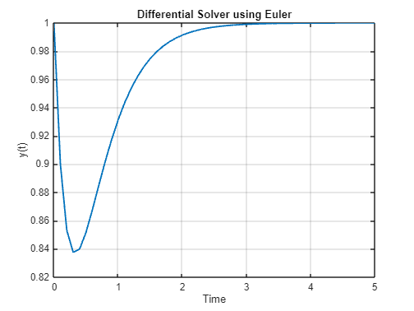
fprintf('Euler Computation Time: %.6f seconds\n', solver1.getComputationTime());
Euler Computation Time: seconds

solver2 = DifferentialSolver(f, [0 5], 1, 0.1, 'Runge-Kutta');
solver2.plotResult();
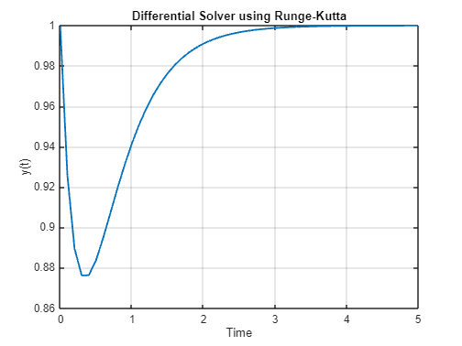
fprintf('Runge-Kutta Computation Time: %.6f seconds\n', solver2.getComputationTime());
Runge-Kutta Computation Time: seconds

%% Integral Example
f2 = @(x) sin(x).^2;
intSolver1 = IntegralSolver(f2, 0, pi, 100, 'Trapezoidal');
intSolver1.plotResult();
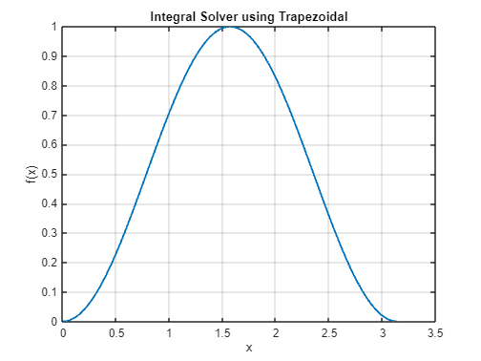
fprintf('Trapezoidal Result: %.6f, Time: %.6f\n', intSolver1.solve().I, intSolver1.getComputationTime());
Trapezoidal Result: 1.570796, Time:

intSolver2 = IntegralSolver(f2, 0, pi, 100, 'Simpson');
intSolver2.plotResult();
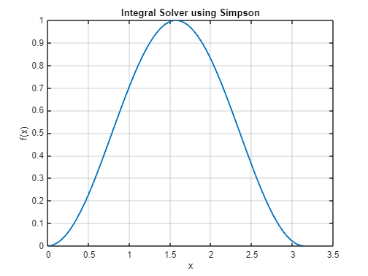
fprintf('Simpson Result: %.6f, Time: %.6f\n', intSolver2.solve().I, intSolver2.getComputationTime());
Simpson Result: 1.570796, Time:

CONCLUSION

The assignment was successful since there was maximum cooperation among group 11 members. It exposed us to the different computation skills on how to of use various numerical methods like newton Raphson, bisection method and Euler method to solve computation problems like knapsack and Fibonacci.

REFERENCES

1. MATLAB PROGRAMMING by T. KIRANI SINGH & B.B. CHANDURI

